**Prediction**

**Q12005 Vs Q22005**

1. **Linear Regression**

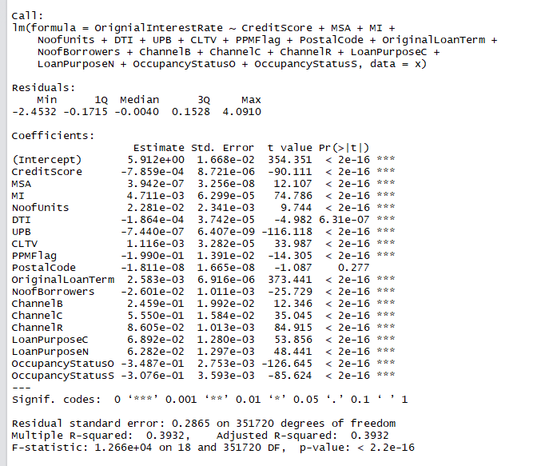

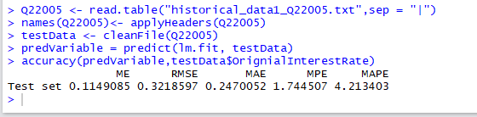

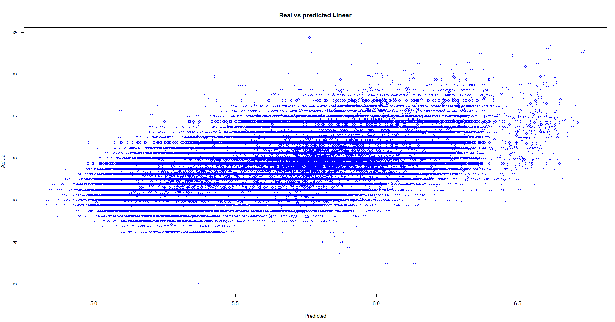

1. **RandomForest**

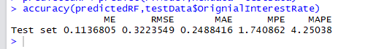

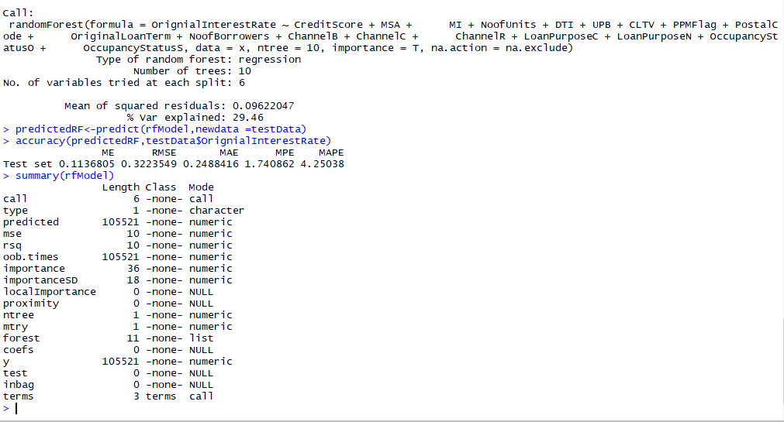

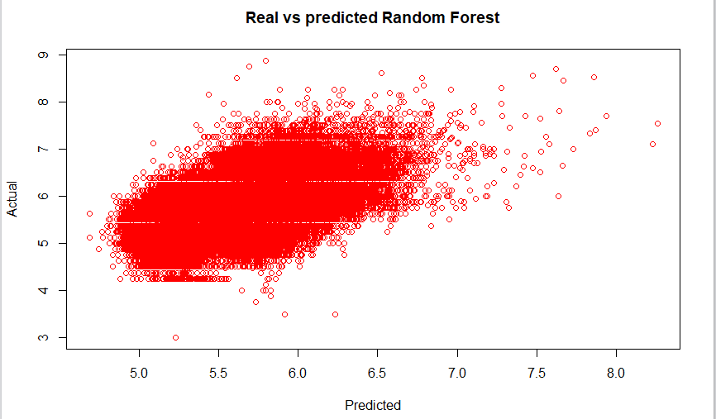

1. **Neural Network**

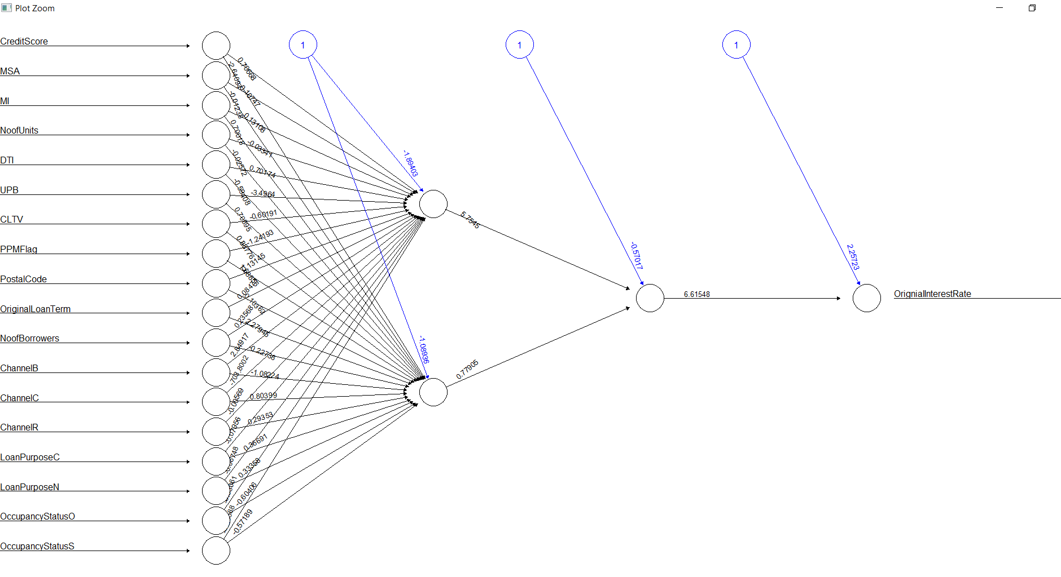

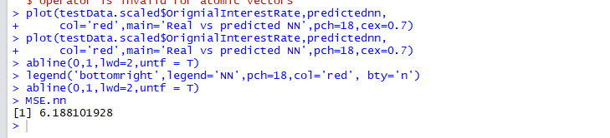

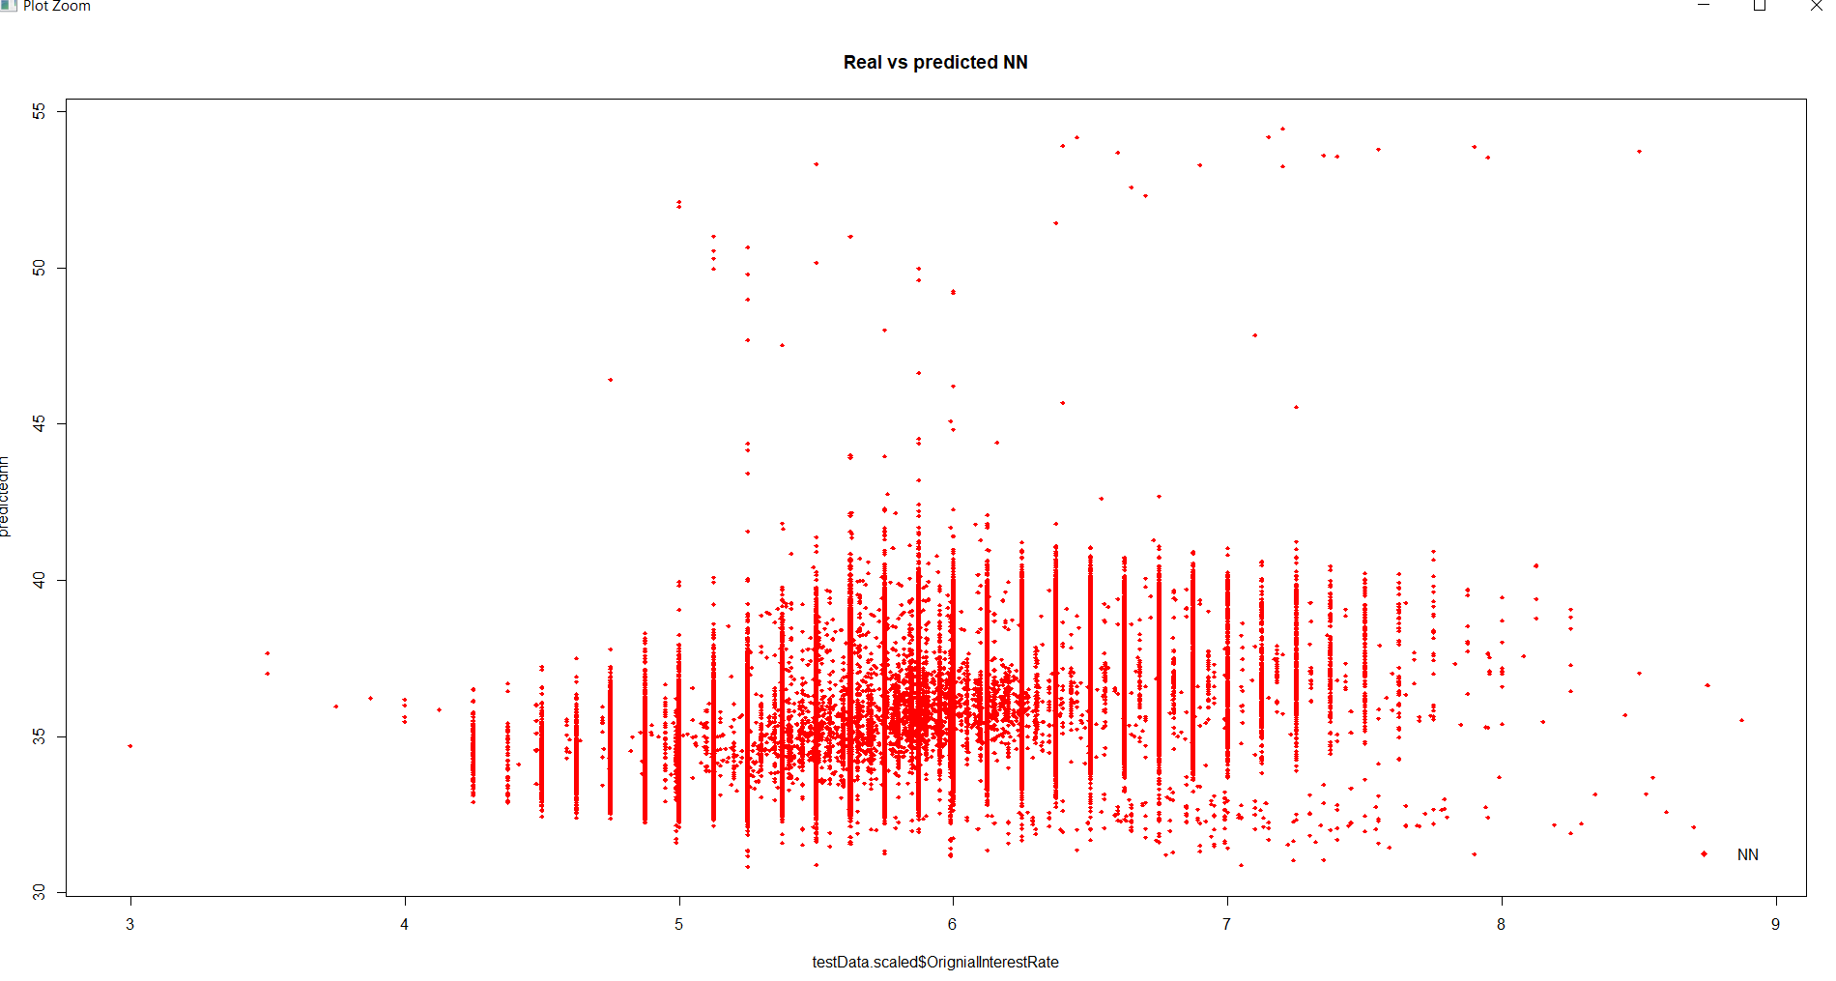

From the 3 algorithms with which the Interest rate is predicted and modelled, I choose Random forest as the best algorithm , the reason being the Mean Error is high for NN Algorithm and the plot of Predicted Vs Actual shows uneven distribution of data and many outliers

Though the Linear regression and random forest give less Root mean square error and Mean absolute error is also similar for both the algorithms, in the Random Forest we have liberty of changing the parameters to optimize the model to fit the data and improve the results.

**Q12007 Vs Q22007**



**Q22007 Vs Q32007**

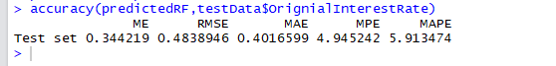

**Q32007 Vs Q42007**

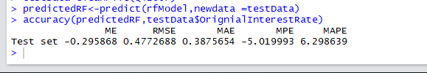

**Q42007 Vs Q12008**

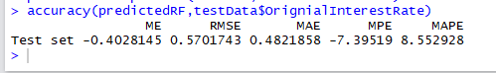

**During the Financial crisis period we could see that the RMSE of the predicted and model increases every quarter during period of 2007 to 2008 which means that in addition to the variables considered for the interest rate prediction there are some other factors might have contributed to the interest rate change**

**Q12009 Vs Q22009**

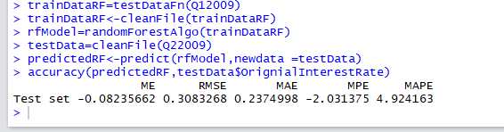

**Q22009 Vs Q32009**

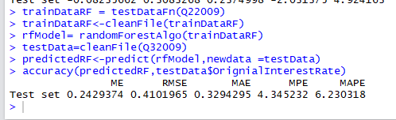

**Q32009 Vs Q42009**

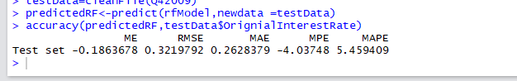

**After two years of economic crisis which lead to the fall in interest rates in 2007-08 seems to have eased and we could see the RMSE values are reasonably small and close to the values of 2005-06 period. In 2009 Obama took measures to increase the refinance homes to bring the economy back on track , the recession ended in the second quarter of 2009 and we could see significant improvement in RMSE during the period from 2008 through Q4 2009**

**Q11999 Vs Q21999**

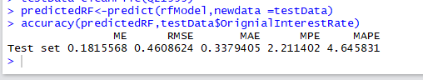

**Q21999 Vs Q31999**

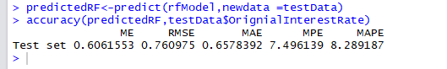

**Q31999 Vs Q41999**

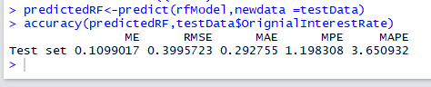

**The Negative Stock Market which occurs in every 4 years seems to have had an impact on the interest rate predictions during the middle of the year 1999 and though the market recovered at the end of the year 1999 the improvement in the RMSE values reflects the market recovery which has impact on the interest rates prediction.**

**Q12013 Vs Q22013**

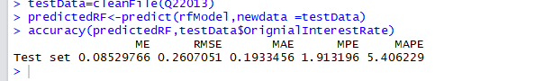

**Q22013 Vs Q32013**

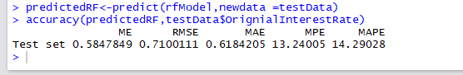

**Q32013 Vs Q42013**

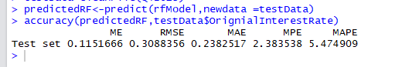

**The bear market occurred in 2008 after the market was down by 20% from its previous high but the market increased twice in % from the previous year in 2013 which led to the higher RMSE values and sudden market rise is not predicted by the model but as soon as the market stabilized by the end of the year the model behaves fairly with reduced RMSE values.**

**Conclusion:**

The Model predicted fairly well for the period in which the model is tested and predicted, there were phases in 2009 , 1999 and 2013 where the model squared errors and variance in the predicted and actual, this is because there are other factors and variables which might have contributed to the Y value i.e. Interest rates. And if the model could accommodate those factors I would recommend to predict for next quarters